**CEMENT INDUSTRY USE CASES**

**PREDICTIVE MAINTENANCE**

1. **Raw Mill Gear Box Failure (Vibration Analysis)**

**Equipment**:

The IDE monitored raw mill gearbox of the capacity 1700 KW and average speed of

990 RPM

**Requirement/Problem**

**Vertical raw mill**

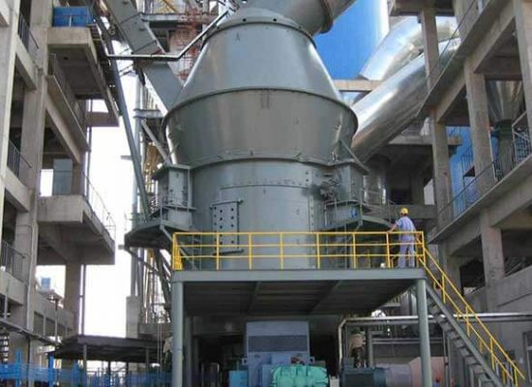

**Horizontal raw mill**

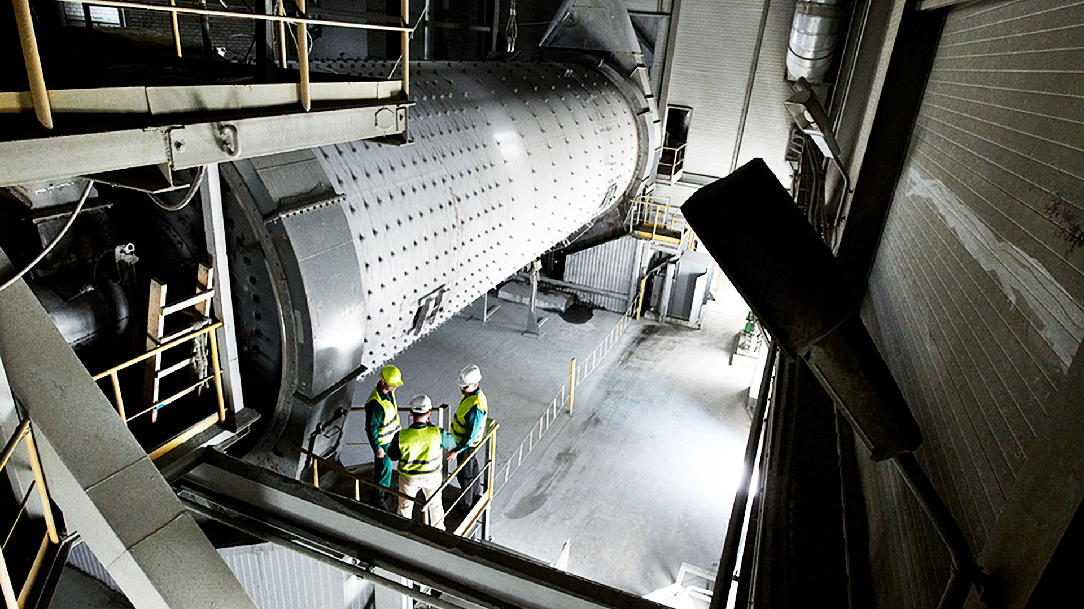

* A raw mill is an equipment used to grind raw materials into raw mix during the manufacturing of cement. Raw mix is then fed to a cement kiln, which transforms it into clinker, which is then ground to make cement in the cement mill. For better performance of the raw mill, A healthy raw mill gearbox is required.
* Try-axial vibration, temperature and noise level were monitored.

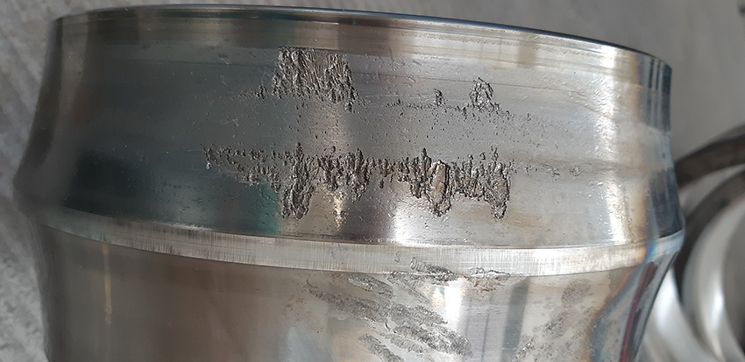

The bearing damage resulted in increased vibration levels in the gearboxes.

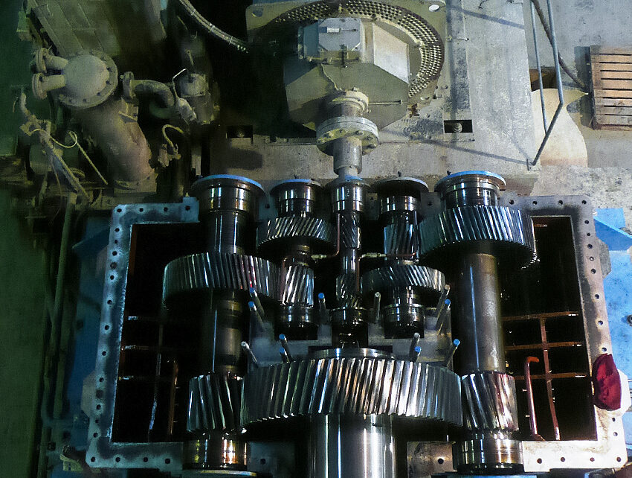

The gearbox at Cement plant

To measure Vibration in gear box we need to use vibration sensors/ transducers at

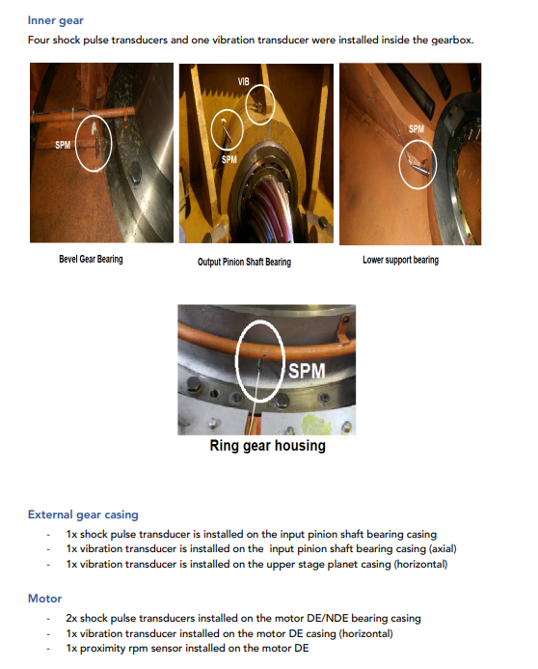

* The limits for vibrations were set considering expertise knowledge and manufacturing standards.

**Solution**:

* Change in vibration pattern was considered as an alert for defect in gear box.

**Benefit**

* Helped in reducing downtime of approximately hours and saved Thousand USD.

**Results**

A spectrum displayed the minor bearing frequencies at the gearbox. The maintenance team

physically inspected the gearbox and observe a problem with lubrication.

The maintenance team performed the lubrication of the gearbox. Lubrication keeps

components from wearing and also keeps them cool. Most gearbox failures are caused

because of improper lubrication.

Recommendation provided by our system:

• To inspect the gearbox immediately.

• To lubricate the gearbox and keeping lubricant clean.

• To fix the gear issues like a bearing problem, misalignment, thermal instability

The Prediction benefitted the manufacturer as follows:

• Saved wear and tear of the gearbox.

• Saved hours of production time costing worth Thousand USD.

• Prevented gearbox failure which could have failed in the raw mill and in turn the plant.

1. **Kiln Cooler Fan/Bearing Failure (Vibration Analysis)**

**Equipment**

The IDE monitored fan motor assembly of the capacity 1200 KW and average speed

of 900 RPM. 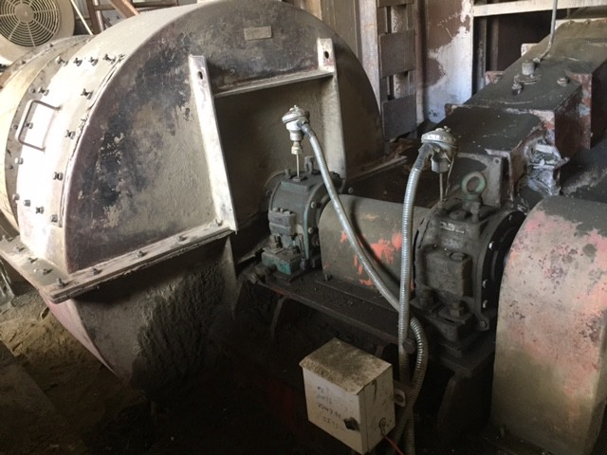

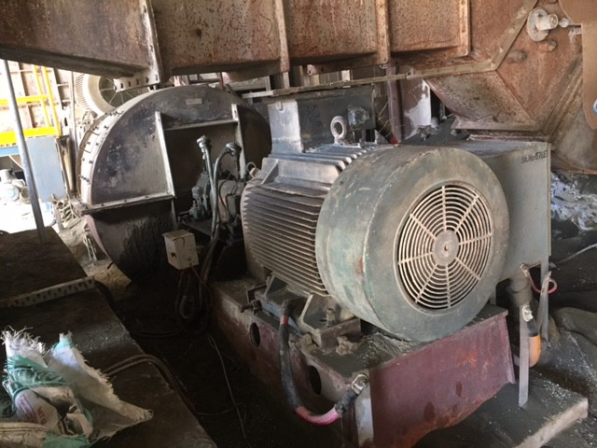

**Pictures of the failed bearing of Fan Non Driven End (FNDE)**

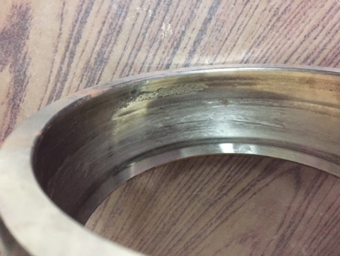 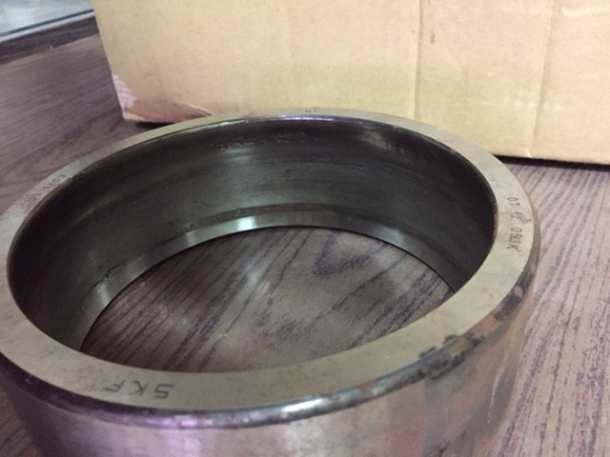

Outer Race Outer Race (another view)

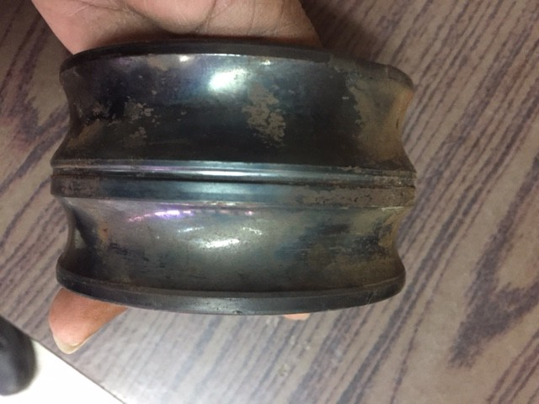

Inner Race

**Requirement/Problem**

Cooling fans are used to blow cold air to the cooler and to cool the clinker from 1500oC to 100oC. It is vital to cool down the kiln shell and bring the temperatures back into balance

and keep within the desired range.

Cooling kiln protects equipment and enables quenching the clinker to ensure the important forms of minerals like C3S,C3A, C2S, C4AF stay in it for maintaining proper clinker quality.

Improper maintenance of cooling fans can lead to poor clinker quality, high power consumption, and even damage to the conveying system.

Speed goes up to 51.2 hz (Threshold is differ )>> resonant frequency excited>> creates axial movement >>force >> distortion of cage and balls >> failure

The fan was performing poorly with an increased level of vibration.

**Solution**

IDEs were installed on fan inboard and outboard bearing. The IDE collected the tri-axial vibrations, temperature, and noise levels of the fan instantly. The limits for vibrations were set considering expertise knowledge and manufacturing standards.

In three days of continuous monitoring, IDE detected high acceleration values i.e. signal energy

indicated excitation in bearing raceway in the outer race. It was an indication of problems in

bearings.

**Benefit**

Helped in reducing downtime of approximately 144 hours, and saved

6.4 Million USD.

**Results**

A spectrum displayed the signal energy excitation in bearing raceway in the outer race. The

maintenance team physically inspected the fan and took a corrective step by isolating

bearings from external vibration and using greases containing antiwear additives. Had the

corrective measures not been taken; it would have certainly resulted in a loss of 144 hours of

production time costing worth 6.4 Million USD loss.

The Prediction benefitted the manufacturer as follows:

• Saved damage of the conveying system.

• Saved clinker quality.

• Saved from sudden plant breakdown.

• Avoided a catastrophic disaster.

1. **Formation of snowman in cooler (Temperature Analysis)**

**Equipment**

Kiln Cooler

**Requirement/Problem**

The so-called snowman in the grate cooler is a name get from the image itself. In fact, it means the clinker accumulates (raw material) under the rotary kiln before go through into cooler which become higher like a snowman. In severe cases, it can be blocked at the kiln outlet and the clinker cannot move out.

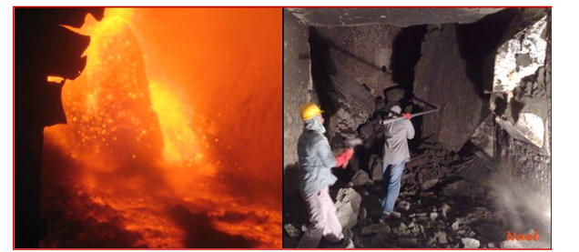

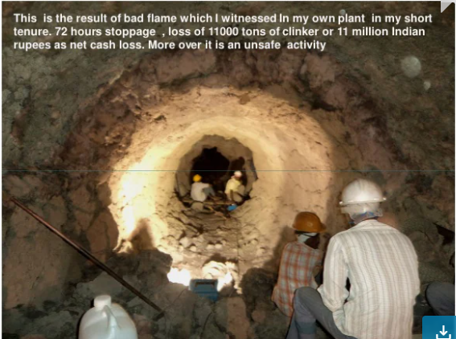

Causes:

1. Improper coordination of cooler and rotary kiln

2. There are more clinker flying sand or large amount of liquid phase.

3. Improper operation of grate bed structure and kiln

4. Improper raw material components

5. Secondary combustion of incompletely burned pulverized coal particles occurs.

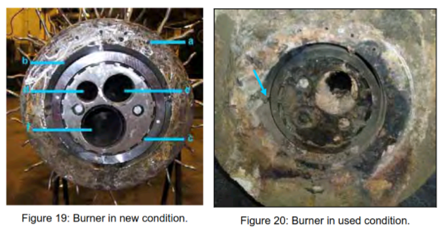

**Solution**

Check high inlet temperature. Clinker build ups at the static inlet of the cooler are mainly formed at clinker temperatures over 1250 °C in the kiln outlet

Stabilize the thermal system in the kiln, avoid excessive kiln temperature and liquid phase quantity, and carefully observe the fire

Appropriately increase the kiln speed and shorten the residence time of materials in the sintering zone;

**Benefit**

**Results/Recommendations**

* Arrange the relative positions of grate cooler and rotary kiln correctly.
* Improve the structure of grate bed;
* The high-sulfur raw coal is limited to the factory and used together to ensure that the SO3 in the pulverized coal entering the kiln does not exceed the standard;
* Appropriately reduce n rate value, increase Fe2O3 content in clinker and ensure clinker granulation.
* kiln head to reduce coal properly, reduce the temperature of burning belt
* Ensure the matching of wind coal, reduce the moisture of coal powder and avoid incomplete combustion.
* It is strictly prohibited to burn the top of the fire in a short time, stretch the flame appropriately and reduce the atmosphere.
* Adjust the shape and position of the flame to prevent coal dust from joining the clinker;
* Increase the cooling air volume, start the air gun, and explode the material;
* If the kiln is seriously stopped, clean it manually from the side inspection opening.

[**https://www.cementequipment.org/home/snowman-formation-and-prevention/#Hypothesis_of_Snowman_formation**](https://www.cementequipment.org/home/snowman-formation-and-prevention/#Hypothesis_of_Snowman_formation)

[**https://www.linkedin.com/pulse/reason-snowman-measures-prevention-linda-gao**](https://www.linkedin.com/pulse/reason-snowman-measures-prevention-linda-gao)

Bearing Failure Detection

Vibration analysis and frequency analysis will help in detecting bearing failure

Case study:

<https://extranet.spminstrument.se/Documents/Downloads/Sales%20packages/Cement/CS_026B_Vertical_rolling_mill_HoangMai_Vn_B.pdf>

Complete cement industries guide

<https://www.eolss.net/sample-chapters/c18/E6-43-34-04.pdf>

Providing Cement industries solution

<https://dalog.net/cloud-based-maintenance-support/>

<http://knowledgeplatform.in/wp-content/uploads/2016/07/Vasavadatta-Cement-CM.pdf>

<https://www.spminstrument.com/measuring-techniques>